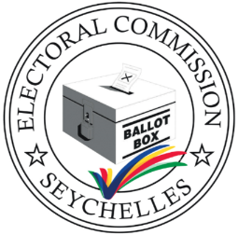

REGISTRATION FORM
Administrators of Social Media Platforms
Name
Surname
NIN
Email
Phone Number
Name of Social Media platforms

CONTACT PERSON: MS. LINA LAURENCE
COMMUNICATION & PR CONSULTANT
communicationspr@ecs.sc

